**Group members:**

MUHAMMAD HAMZA 21I-1656

HAMMAD JAVAID 21I-1661

AHMAD AKHTAR 21I-1655

Differential Equation

**Goal:**

this project was to analyze data using

differential equations. we used the initial values to plot different types of graphs with the help of Mat-lab.

**Question:**

1. Problem Statement

Each of the tanks shown in the Figure below contains a brine solution. Assume that Tank 1 initially contains

30 gallons (gal) of water and 55 ounces (oz) of salt, and Tank 2 initially contains 20 gal of water and 26

oz of salt. Water containing 1 oz/gal of salt flows into Tank 1 at a rate of 1.5 gal/min, and the well-stirred

solution flows from Tank 1 to Tank 2 at a rate of 3 gal/min. Additionally, water containing 3 oz/gal of salt

flows into Tank 2 at a rate of 1 gal/min (from the outside). The well-stirred solution in Tank 2 drains out

at a rate of 4 gal/min, of which some flows back into Tank 1 at a rate of 1.5 gal/min, while the remainder

leaves the system.

Note that the volume of solution in each tank remains constant since the total rates of flow in and out of each

tank are the same: 3 gal/min in Tank 1 and 4 gal/min in Tank 2.

(a) Denoting the amount of salt in Tank 1 and Tank 2 by Q1(t) and Q2(t), respectively, use the principle of

mass balance to show that

dQ1

dt = −0.1Q1 + 0.075Q2 + 1.5,

dQ2

dt = 0.1Q1 − 0.2Q2 + 3,

Q1

(0) = 55 , Q2 (0) = 26.

(b) Write the initial value problem (i) using matrix notation.

(c) Find the equilibrium values Q1

E and Q2

E of the system.

(d) Use MATLAB to draw component plots of the initial value problem (i), and the equilibrium solutions,

over the time interval 0 ≤ t ≤ 50.

(e) Draw a phase portrait for the system centered at the critical point using MATLAB

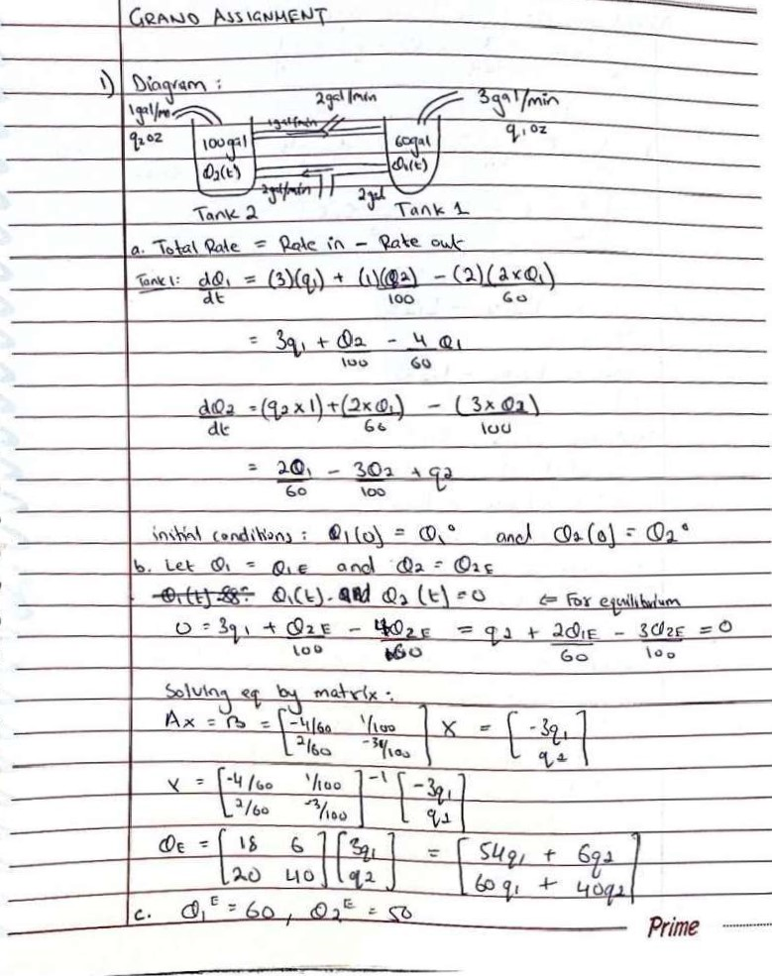

# Matlab Code:

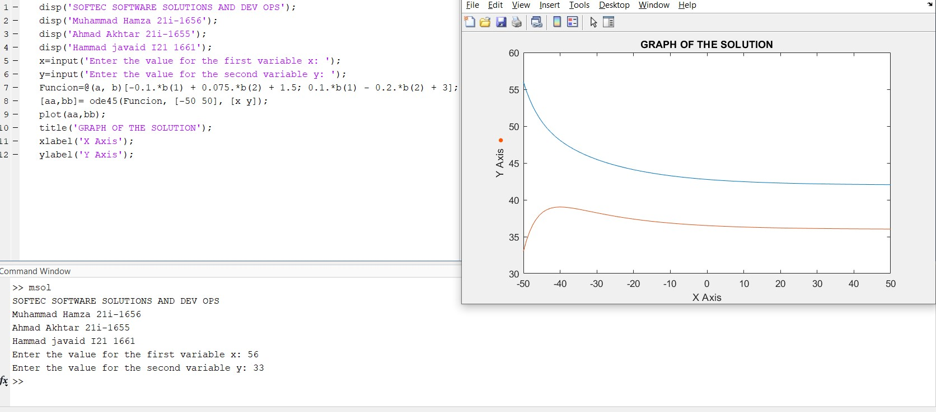

# About code:

* ‘**disp’** displays all the relevant data.
* The input functions ask the user for values. If the user does not provide the value then the function runs on the stored default value.
* The ode command solves the initial value problem.
* The plot function plots the values.

**AIM:**

The main aim of this project was to know how the ordinary

differential equations are solved.

**PARTNERSHIP:**

The project was divided among our group equally. HAMZA, AHMAD, and HAMMAD wrote codes on **Matlab** . Different sections of the report were solved by all three members.